KH100 + Full Function Key Assistant
user's manual

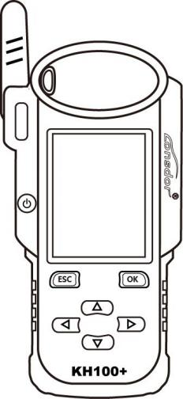

Please read the operating instructions carefully before using the ★

KH100+

A ll right reserved
Lingshida owns such intellectual property rights as all the contents of its products or services, and the materials and software on the relevant websites of Lingshida, which shall be protected by law.Without the written permission of the Company, no unit or individual shall copy, modify, copy, disseminate, sell any part of the above products, services, information, materials or bundle with other products in any way or reason.Any infringement of the company's copyright and other intellectual property rights, our company will investigate its legal responsibility according to law!

P roduct
Lingshida KH100 + full-function key assistant and its related information are only used for normal maintenance, diagnosis and detection of cars, and should not be used for illegal behaviors.The Company shall not bear any legal liability for using our products.This product has certain reliability, but does not exclude the possible loss and damage, the risk will be borne by the user, the company will not bear any risks and responsibilities.
Declaration unit: Lingshida Legal Affairs Department
Declaration unit: Lingshida Legal Affairs Department

KH100+

safety instruction
Read this section and learn this before using this product.For more detailed information, see the appendix.
1. Do not hit, throw or needle the product, and avoid falling, squeezing and bending.
2. Do not use the product in a humid environment such as the bathroom, and avoid the product being soaked or washed by liquid.Close the product where the product is prohibited or where the product can cause interference or danger.
3. Do not use this product when driving a car, so as not to hinder safe driving.
4. In medical places, please abide by the relevant regulations or regulations.Close the area near the medical equipment.
5. Please close the product near the high-precision electronic equipment, otherwise the electronic equipment may fail.
6. Do not disassemble the product and accessories without authorization, and only an authorized agency can repair it.
7. Do not place the product and accessories in appliances with powerful electromagnetic field.
8. Please remove the product from the magnetic device, whose radiation will erase the information stored on the product.
9. Do not use this product in high temperature places, where there are flammable gases (such as near gas stations).
10. When using the product, please abide by relevant laws and regulations, and respect the privacy and legal rights of others.
KH100+

catalogue
Copyright Statement ……………………………………………………………………………1
Safety notice ……………………………………………………………………………2
Directory: …………………………………………………………………………………3
chapter one.Register the boot …………………………………………………………………4
chapter two.Product Overview of …………………………………………………………………5
2.1 Product Description: ………………………………………………………………5
2.2 Product features: ………………………………………………………………5
2.3 Product Parameter ………………………………………………………………5
2.4 Introduction of the whole machine: ………………………………………………………………6
2.5 Function Introduction to ………………………………………………………………7
2.5.1 Identification of the copy of the ……………………………………………………………7
2.5.2 Access Control Garage ……………………………………………………………7
2.5.3 Chip analog ……………………………………………………………8
2.5.4 Chip generates ……………………………………………………………8
2.5.5 The …………………………………………………………… is generated by remote control9
2.5.6 Smart Card Generates …………………………………………………………9
2.5.7 Coil Identification ……………………………………………………………9
2.5.8 Remote control frequency detection of ………………………………………………………10
2.5.9 Special function ……………………………………………………………10
2.6 Upgrade the ……………………………………………………………………11
chapter three.After-sales service to …………………………………………………………………12
Warranty Service Card for ………………………………………………………………………14

KH100+

Chapter 1:, Registration guidance
N ote: After startup, please connect to WIFI and enter the registration process.
N ewly registered users

① First using , please prepare a common call phone or email to help complete the login activation process, click OK to start.
② The machine is started into the registration and activation process.
③ Enter the name, password, confirmation password, mobile phone number or email account, obtain the verification code, enter the verification code to submit notes
volume.
④ registered an account successfully, binding the device, about 5 seconds.
The ⑤ was registered successfully and entered the system.
Registered user

① For the first use of please prepare the mobile phone or email corresponding to the existing account to complete the registration and activation process, and click OK to start.
② The machine is started into the registration and activation process.
③ Enter the mobile phone number or email account number, password, obtain verification code, enter verification code to submit login.
④ login account success, binding device, about 5 seconds.
The
⑤ was registered successfully and entered the system.
In addition, users who have registered the products can activate them directly through "registered users".

KH100+

Chapter 2:, Product overview
2.1 Product Introduction

Product name: KH100 + full-function key Assistant
Product introduction: KH100 + is Shenzhen lead world technology co., LTD., launched a multi-function intelligent key handheld equipment, the equipment contains the chip identification copy, access key copy, chip simulation, chip generation, remote control, smart card machine generation, remote control, infrared signal detection, intelligent sensing area detection, anti-theft system detection, Toyota smart card unlock and other special functions.

2.2 Product Features

1. Modern appearance design, in line with the operation habits of the public users;
2. Built-in operation instructions to make it easier for users to get familiar with the function;
3. It covers almost all the functions of the same product on the market;
4. Built-in supersensor (data collection beyond the range);
5. Take the lead in supporting 8A type (H chip) chip generation;
6. Built-in WIFI module, you can connect to the network at any time.

2.3 Product parameters

Equipment size: 193mm * 88mm * 24mm
Screen size: 2.8 inches
Resolution: 320X240
Battery: 3.7V 2000mAh
Power supply: 5V 1A
Operating temperature: -5℃ ~60℃
USB: USB-B / Charge-Data transfer
Cable interface: PS2 male socket + 1.25mm spacing 6PIN terminal cable

2.4 The whole machine introduction

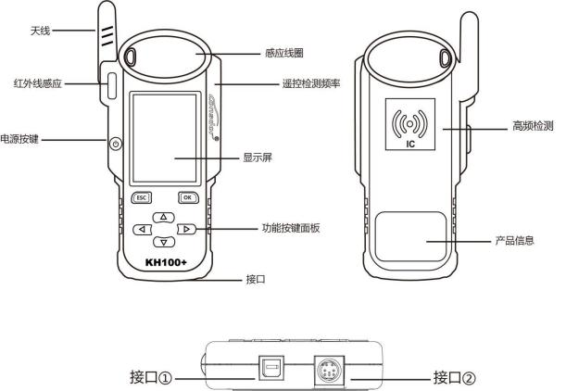

Name | instruction
antenna | Induction analog chip and detection ignition coil
induction coil | For identifying, copying, generating chips, remote control, etc
display screen | A 2.8-inch color screen, with a resolution of: 320X480
Interface 1 | USB-B joggle
Interface 2 | Sub-machine line interface
Power button | Long press for 3 seconds to boot up  Long press for 4 seconds to shut down
Remote control detection frequency | Place the remote control in this position to detect the remote control frequency
High frequency detection | IC card recognition and copy

KH100+

2.5 Function introduction
After completing the registration and activation, enter the menu interface, as shown below:

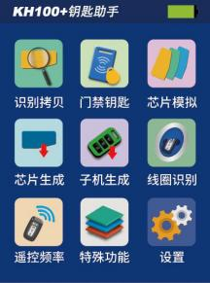

2.5.1 Identification copies
Enter the identification copy menu and operate according to the prompts (as shown):

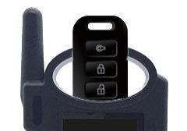

2.5.2 Access control key
Enter the access control key menu and operate according to the prompts (as shown here):
Enter the access control garage menu, can be IC card identification and copy, can be ID card identification and copy, can generate the garage door key.Operation as prompted (as shown):

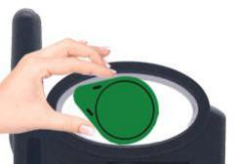

ID card identification

KH100+

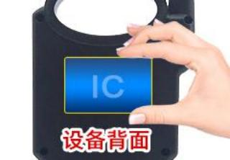
IC card identification

2.5.3 Chip simulation
Place the KH100 + antenna at the ignition switch (as shown in the figure) and select the corresponding chip type for simulation operation. This equipment supports the following chip types:
① 4D Chip Analog ② 46 Chip Analog ③ 48 chip analog ④ 47 chip analog

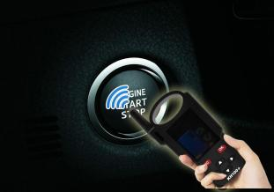

2.5.4 Chip generation
Put the following types of chips into the induction slot (as shown here), select the corresponding chip, and operate according to the prompts,
This device supports the following types of chip generation:
① 4D Type ② 46 Type ③ 48 Type ④ T5 Type ⑤ 7935 Type ⑥ 8A Type ⑦ 4C chip ⑧ chip conversion

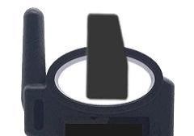

Note: Some chip data will be overwritten and locked.

2.5.5 Remote control generation
Use the subsystem cable to connect with the remote control subsystem, enter the remote control generation menu, and select the corresponding model according to different regions (as shown in the picture):

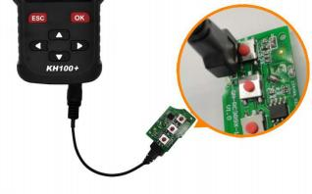

2.5.6, Smart card generation
Use the subsystem cable to connect to the smart card subsystem, enter the smart card generation menu, and select the corresponding model to conduct the smart card generation operation according to different regions (as shown in the picture):

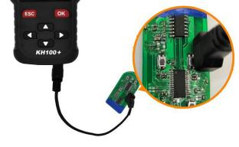

2.5.7 Coil identification

① Smart Sensor Zone lookup
Keep the KH100 + antenna close to the predicted position, and if the induction signal machine will sound continuously, check whether the position is correct (as shown):

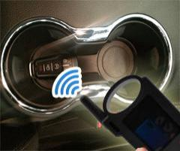

KH100+

② anti-theft system detection
Put the KH100 + antenna close to the key identification coil, open the key to the ON position, and the KH100 + buzzer sends out sound instructions to identify the signal (see the picture):

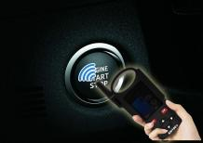

2.5.8 Remote control frequency detection
Enter the remote control frequency detection menu and place the remote control in the equipment induction area for remote control frequency detection (as shown):

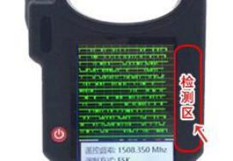

2.5.9 Special functions

Special functions include: infrared signal detection, Toyota smart card unlock, FT smart key, key charging, subsequent upgrade and more functions...
① infrared signal detection
Place the remote control in the infrared signal detection area, press the remote control button, the KH100 + screen indicates infrared signal, otherwise no signal (as shown):

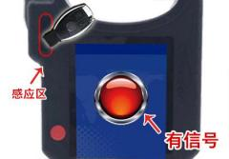
Figure 1: There is a signal

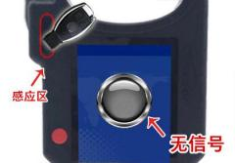
Figure 2:, No signal

KH100+

The ② FT Smart Key
For the FT series Toyota / Lexus smart card launched by Lynida, you can read version information, modify key values, unlock and upgrade programs and other related functions.Add the smart card and click "Select" (as shown):

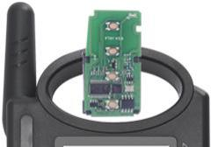

③ Toyota Smart Card Unlocked / Status Detection
Put in the smart card and click "execute" (see the picture):
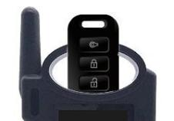

④ key charging
For the rechargeable key, it can be charged.Place the rechargeable key and click "OK" (as shown):

2.6 Upgrade
Enter the Settings menu, connect to WIFI, select check the update, one key online upgrade.

KH100+

Chapter 3:, After-sales service
1. Our company will provide high-quality after-sales service and agreed warranty services for this product;

2. The warranty period is for 12 months from the equipment activation date;

3. Once the product is sold, non-product quality problems will not be accepted;

4. For the maintenance of the products beyond the warranty scope, our company will charge the labor and material costs;

5. If the equipment fails or damages due to any of the following reasons, we shall have the right not to provide services in accordance with the agreed terms (but you can choose to pay for services);
· The whole machine and its parts have exceeded the warranty period;
· Non-company product quality problems, appearance defects or damage found by user use;
· Non-genuine, without certificate, unable to authenticate the equipment information in our official background system;
· Failure to operate, use, store and maintain according to this instructions. And causes product damage;
· Damage caused by unauthorized dismantling, or damage caused by maintenance and modification by the maintenance unit approved by our company;
· Fluid, damp, water, or moldy;
· The newly purchased equipment and the unpacking equipment runs normally without any damage, and any screen damage caused by later use, such as screen explosion, scraping, white dot, black dot, wire screen, touch damage, etc.;
· Damage caused by the use of special wires and accessories not provided by our company;
· Damage caused by force majeure;
· If the man-made damaged machine chooses not to be repaired after dismantling the machine with a quotation, the unstable condition of the machine occurs after returning to the user (such as: unable to boot, crash and other problems);

· Self-cracking of the system leads to systematic function changes, instability and quality damage of the equipment;

6. If the auxiliary parts and other parts other than the main parts of the equipment fail, you can choose the paid maintenance service provided by our company or the customer service outlets authorized by our company;
7. After receiving the equipment returned to the customer and determining the equipment problems, please be sure to fill in the detailed problems;

8. After the maintenance, the equipment will be returned to the customer, and the customer must fill in the true and accurate address and contact number;

9. If the customer needs to return to the factory for maintenance, the transportation expenses and transportation expenses shall be borne by itself. If the equipment is damaged during the transportation, our company shall not bear the relevant expenses, and shall assist the customer to recover compensation from the transportation unit under special circumstances;

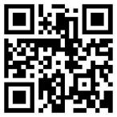
KH100+

10. Our company shall not provide sales invoices to individual customers in any form. If you need them, please apply to your purchased dealer;
11. Please keep the warranty service card properly and fill in this card when returning to the factory for maintenance so that our company can handle relevant work procedures: (the tail of the instructions of the warranty card);
12. After-sales service hotline: 400-966-9130;
Wechat: guopi0001 guopi0004;
Service time: Monday to Sunday 9:00-12:00 13:30-18:00 (holiday rest);
official website:,www.lonsdor.com

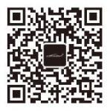
Public account QR code official website QR code

KH100+

Warranty Service Card

Customer name: ___________________________________________ (Mr. / Miss) Contact number: _________________________________________________________ Customer Address: _________________________________________________________
___________________________________________________________________
Equipment model: _________________________________________________________ Serial number: ____________________________________________________________ Return to the factory with accessories (details): _____________________________________________
___________________________________________________________________
Device issues (detailed): _________________________________________________

___________________________________________________________________

___________________________________________________________________

Repair and factory return time: _____________________

The Company reserves the right of final interpretation of the above terms.

KH100 +FULL-FEATURED KEY MATE

USER MANUAL

★ Plea se read this instruction manual carefully before use.

KH100+

COPYRIGHT STATEMENT

All rights reserved!
The entire copyrights and intellectual property rights of Lonsdor, including but not limited to products or services issued by itself or co-issued with partner company, and the materials and software on the related websites of the company, are protected by law.Without the written permission of the company, no unit or individual may copy, modify, transcribe, transmit or bundle or sell any part of the above products, services, information or materials in any way or for any reason.Anyone who infringes the copyrights and intellectual property rights will be held accountable in accordance with the law!

Product
The Lonsdor KH100+ full-featured key mate and related materials are only used for normal vehicle maintenance, diagnosis and testing, and should not be used for illegal activities.If you use our products to violate laws and regulations, the company does not assume any legal responsibility.This product has certain reliability, but does not exclude the possible losses and damages, the risks arising from this shall be borne by the user, and our company does not bear any risks and liability.

Declared by: Lonsdor Dept of Legal Affairs

1

KH100+
SAFETY INSTRUCTION

Before use this product, please read this instruction carefully to know how to use it properly.
(1) Do not hit, throw, acupuncture the product, and avoid falling, squeezing and bending it.
(2) Do not use this product in damp environment such as bathroom, and avoid it being soaked or rinsed with liquid.Please turn off the product in circumstances when it 's forbidden to use, or if it may cause interference or danger.
(3) Do not use this product while driving a car, so as not to interfere with safety driving.
(4) In medical establishments, please follow the relevant regulations.In areas close to medical equipment, please turn off this product.
(5) Please turn off this product near high-precision electronic equipment, otherwise the equipment may malfunction.
(6) Do not disassemble this product and accessories without authorization.Only authorized institutions can repair it.
(7) Do not place this product and accessories in appliances with strong electromagnetic fields.
(8) Keep this product away from magnetic equipment.The radiation from magnetic equipment will erase the info/data stored in this product.
(9) Do not use this product in places with high temperature or inflammable air enviroment(such as near gas station).
(10) When using this product, please comply with relevant laws and regulations, and respect the privacy and legal rights of others.

2

KH100+

CONTENT

COPYRIGHT STATEMENT...........................................................................................................1

SAFETY INSTRUCTION.................................................................................................................2

CONTENTS 3.....................................................................................................................................

1.0 Registration guide 4.........................................................................................................

2.0 Product overview 5............................................................................................................

2.1 Product introduction 5..........................................................................................
2.2 Product features 5...................................................................................................
2.3 Product parameter 5...............................................................................................
2.4 Device components 6..............................................................................................
2.5 Function introduction 7..........................................................................................
2.5.1 Identify Copy 7............................................................................................
2.5.2 Access Control Key 8...............................................................................
2.5.3 Simulate Chip 8..........................................................................................
2.5.4 Generate Chip 9..........................................................................................
2.5.5 Generate Remote 9...................................................................................
2.5.6 Generate Smart key(card) 9...................................................................
2.5.7 Identify Coil 10.............................................................................................
2.5.8 Remote Frequency 10..............................................................................
2.5.9 Special functions 11...................................................................................
2.6 Function introduction 12.......................................................................................

3.0 After-sales service 13.........................................................................................................

Warranty card 15................................................................................................................

3

KH100+

1.0 Registration guide

Note: After booting the device, please connect to WIFI and enter the following process.
New user

① For the first use, please prepare a common call phone or email to help complete activation process, click OK to start.
② Boot the device and enter registration activation process.

③ Input user name, password.Confirm password, cellphone number or email to obtain verification code.Then input the code to submit registration.
④ Account registered successfully, it will take 5 seconds to bind the device.⑤ Successful registration, enter the system.
Registered user（who has registered Lonsdor products before）

① For the first use, please prepare a registered call phone or email to help complete
activation process, click OK to start.

② Boot the device and enter registration activation process.

③ Input your registered mobile number or email, password to obtain verification code.
Then input the code to submit login.

④ Account login succeeded, it will take 5 seconds to bind the device.
⑤ Successful registration, enter the system.

In addition, users who have already registered Lonsdor’s product can directly choose [registered user] to activate account.

4

KH100+

2.0 Product overview
2.1 Product introduction

Product name: KH100+ full-featured key mate
Description: KH100+ is a versatile handheld smart device, launched by Shenzhen Lonsdor Technology Co., which includes special features and functionality, such as: identify&copy chip, access card cloning, simulate chip, generate chip, generate remote (key), generate smart key(card), detect remote frequency, detect infrared signal, search induction area, detect IMMO, unlock Toyota smart key and etc.

2.2 Product features

※ Modern appearance design, in line with the operating habits of the public.※ Device system comes with operation instructions, easier for you to use.※ It covers almost all the functions of the similar products in the market.※ Built-in super sensor to collect data(over-range data collection).※ Exclusive support for 8A(H chip) generation.
※ Built-in WIFI module, can connect to network at any time.

2.3 Product parameter

Device dimension: 193MM*88MM*24MM
Screen size: 2.8 inch
Screen resolution：320X240
Battery: 3.7V 2000MAH
Power: 5V 1A
Work temperature: -5℃~60℃
USB: USB-B/charge-data transfer
Connector port: PS/2 +1.25mm spacing, 6PIN terminal

5

KH100+

2.4 Device components

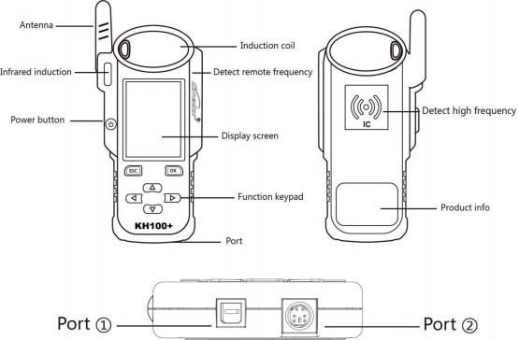

Name | Notes
Antenna | To induce simulated chip and detect ignition coil
Induction coil | To identify, copy, generate key chip or remote, etc.
Display screen | 2.8-inch color screen, resolution: 320X480
Port 1 | USB-B port
Port 2 | Dedicated port for remote 's connector
Power button | Long press 3s to boot.  Long press 4s to shut down.
Remote frequency detection | Put remote in this position to detect its frequency.
High-frequency detection | To identify and copy IC card.

6

KH100+

2.5 Function introduction

When complete the registration activation, it enters below menu interface:

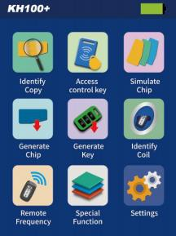

2.5.1 Identify Copy

Enter this menu, follow system prompts to operate (as shown).

7

KH100+

2.5.2 Access card cloning

Enter this menu, you can identify and copy IC card, and generate garage key as well.Follow the prompts to operate(as shown below).

Identify ID card

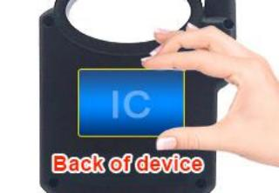

Identify IC card

2.5.3 Simulate Chip

Put KH100+’s antenna at the ignition switch(as shown), choose the corresponding chip type to simulate.This device supports below chip types:

①4D ②46 ③48

2.5.4 Generate Chip

④47

8

KH100+

Put below types of chip into the induction slot(as shown), choose the corresponding chip to operate according to the prompts.
This device supports below chip types:

①4D ⑤7935

②46
⑥8A

③48
⑦4C

④T5
⑧Chip conversion

Note: some chip data will be covered and locked.

2.5.5 Generate Remote
Enter [Generate key]->[Generate remote], choose the corresponding vehicle type to generate remote control(as shown) according to different regions.

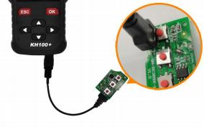

2.5.6 Generate Smart key(card)

Enter [Generate key]->[Generate smart key] menu, choose the corresponding vehicle type to generate smart key/card(as shown) according to different regions.
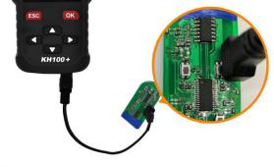

2.5.7 Identify Coil

9

s antenna close to key KH100+ buzzer beeps, it
KH100+

1 Search smart induction area

Connect remote key with remote connector, Put KH100+’s antenna close to the pre-determined position.If inductive signal is identified, the device will continuously make sounds, please check if the position is right(as shown below).

②Detect IMMO

Connect remote key with remote connector, Put KH100+’
identification coil, and use key to turn ignition ON.When
means signal is detected.

2.5.8 Remote Frequency

Enter this menu, put remote control at the device’s induction area to detect remote frequency.

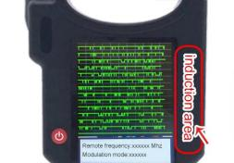

2.5.9 Special function

10

KH100+

1 Include: detect infrared signal, unlock Toyota smart key, FT Toyota smart key, Charge key,
More functions, to be continued...
2 Detect infrared signal

Put remote control at the infrared signal detection area, press the remote's button once.When the light on KH100+'s screen is on, it indicates there is infrared signal, otherwise there is no signal(see below pic).

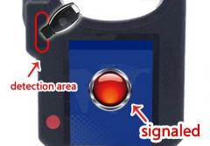
P1: signaled

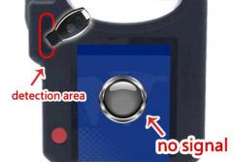
P1: no signal

3 FT smart key

For Toyota or Lexus smart keys from Lonsdor, you can perform the following functional operations: read version info, modify key value, unlock and upgrade program and etc.Put in the smart key, click [select] to operate.

11

KH100+

4 Unlock Toyota smart key/detect Toyota key status

Put in the smart key, click OK to operate.

5 Charge key

For a chargeable key with battery, you can perform this function.Put in the key, click [OK] to operate.

2.6 Upgrade
Enter settings menu, and connect the device to network, then choose [check for updates], one-click online upgrade.

12

KH100+

3.0 After-sales service
(1) Our company will provide you with excellent after-sales service and warranty service within agreed time.
(2) The warranty period lasts 12 months from device activation date.
(3) Once the product is sold, the return and refund will not be accepted if there is no quality problem.
(4) For product maintenance beyond the warranty period, we will charge labor and material costs.
(5) If the device is faulty or damaged due to any of the following reasons, we reserve the right not to provide service based on the agreed terms(but you can choose paid service).
※ The device and components are beyond the warranty period.
※ Users find that the product appearance is flawed or damaged, but has no quality problem.
※ Counterfeit, without certificate or invoice, our official back-end system can not authenticate the device info.
※ The product is damaged due to not following the instructions in this manual for operation, use, storage, and maintenance.
※ Damage caused by personal disassemble or damage during repairing or
maintenance by unauthorized third party.
※ Liquid inflow, moisture, falling into water or mildewing.
※ The newly purchased device works normally without any damage when unpacked for the first time.But with the prolonged time of use, screen damage occurs, such as screen explosion, scratching, white spots, black spots, silk screen, touch damage, etc.
※ The use of special tools and accessories not provided by our company.
※ Force majeure.
※ For the man-made damaged device, if you decide not to repair after we disassemble it and make a quotation, the device appears unstable condition(such as: unable to boot, crash, etc) when you receive it.
※ Private cracking of the system causes function changes, instability, and quality damage.

13

KH100+

(6) If the auxiliary parts and other parts(other than the main components of the device) are faulty, you can choose the paid repair service provided by our company or our authorized customer service outlets.
(7) We will perform repair after receiving your device and confirming its problems, so please fill in the problems in details.
(8) After repair finished, we will return the device to customer, so please fill in the correct delivery address and contact number.
(9) Customers who needs to send the device for repair, shall bear the cost, such as round-trip delivery cost, transportation cost and etc.If the device is damaged in the process of delivery, our company will not bear relevant fees.In particular cases, we will assist the customer to claim for compensation against the shipping company.
(10) We do not provide sales invoice to individual in any form.If need it, please ask the dealer you purchased from to invoice you.
(11) Please keep the warranty card properly, and fill in the card when returning your device for repair, so that we can deal with the relevant work procedures(the warranty card attached to the end of the manual).
(12) Service Hours: Monday to Saturday: 9:00-12:00 13:30-18:00; legal holidays excluded.Email: service@lonsdor.com

14

KH100+

Product Warranty Card

Customer name: ___________________________________________ ( Mr/Ms ) Phone No.: __________________________________________________________ Customer address: ___________________________________________________
_____________________________________________________________________
Device model: ______________________________________________________ Serial No.: _________________________________________________________ Returned items (details): ___________________________________________
___________________________________________________________________
Problem description in details: _____________________________________

_______________________________________________________________________

______________________________________________________________________

Sending date:_____________________

(Note: our company reserves the final interpretation right for the above terms.)

15

