How To Update The DS708 By Update Card

After one year, if you still want to update your DS708, You can buy the DS708 update Service from us. Then we will send you the DS708 update card, now I will tech you how to do it

1.Sigh in To your Autel Account

You need to go to the office website: www.auteltech.com, sign in to the account which corresponding the DS708 serial number need to upgrade, Please confirm the account can be used

2.Enter the Autel ID And password as follow picture:

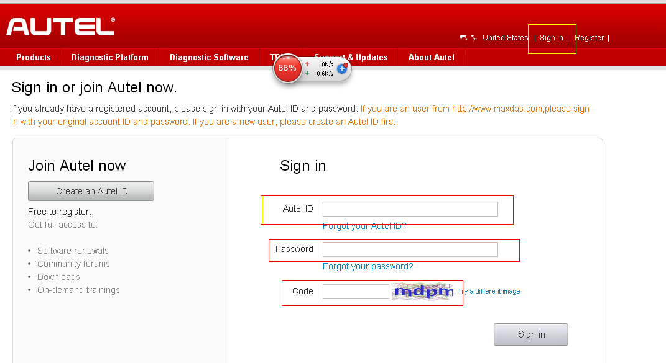

3. when you go to the account, Select the Redeem from the left

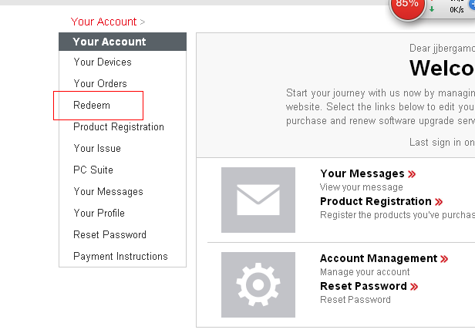

4. You will see the picture as follow:
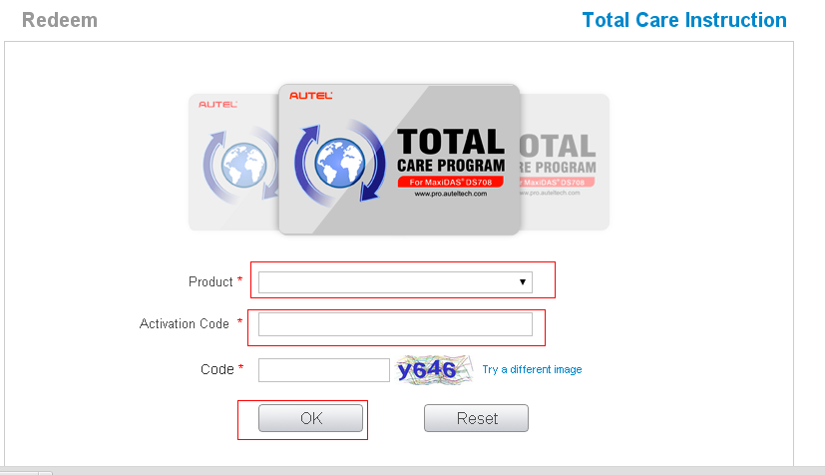

5.Insert information to the top of picture:

- Chose the Product, it will shows your DS708 Serial number
- Insert the Activation code
- Press OK bottom to confirm
- Your DS708 one year update Online is complete

6. How To Get the Activation Code?
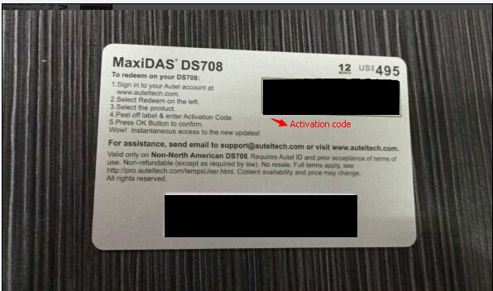

- Once you buy the DS708 Update service From Autelshop.com, we will send you the screenpost of DS708 update card as top of picture. of course you can see the activation code and password from this two black site.

2)It only need 5-10 minute to update it by yourself

3)If you really did not know how to do ,You can also offer us your Autel accout ID, Password and also your DS708 Serial number, we will help you do it

Note:

1.If you have submitted more than 5 times of the wrong password in One day, the update service will be temporarily disabledday.

2. This Update card is Disposable, which can only update one DS708

