Fix CAT ET Not Supported error
When use CAT2/3 to test some truck models, like Hyundai excavator with Mitsubishi Engine, maybe it will read error message "Not Supported".
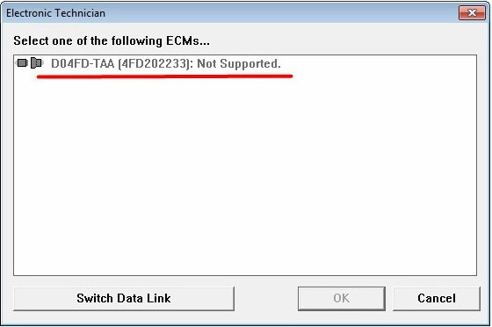
This is not the fault of Hardware, but the fault of software registration, to solve this error, please select "Subscription: NEXG5006 Factory"

