Declaration

1. This manual is designed for the usage of HD900. No part of this manual can be reproduced, stored in a retrieval system or transmitted, in any form or by any means (electronic, mechanical, photocopying, recording, or otherwise), without the prior written permission of Xtool.
2. HD900 is just designed for the professional vehicle repair or maintenance technicians.
3. Use the device only as described in this manual. The user will be responsible solely for the after-effects of violating the laws and regulations caused by using the product or its data information, in this case Xtool will not bear any legal responsibility.
4. Xtool shall not be liable for any incidental or consequential damages or for any economic consequential damages arising from the accidents of individual users and the third parties, misuse or abuse of the device, unauthorized change or repair of the device, or the failure made by the user not to use the product according to the manual.
5. All information, specifications and illustrations in this manual are based on the latest configurations and functions
available at the time of printing. Xtool reserves the right to make changes at any time without notice.
6. is the registered trademark of SHENZHEN XTOOLTECH CO.,LTD.
7. In countries that the trademarks, service marks, domain names, logos and the name of the company are not registered, Xtool claims that it still reserves the ownership of the unregistered trademarks, service marks, domain names, logos and the company name. All other marks for the other products and the company’s name mentioned in the manual still belong to the original registered company.
You may not use the trademarks, service marks, domain names, logos and company name of Xtool or other companies mentioned without written permission from the trademark holder.
8. Please visit www.xtooltech.com for more information on the HD900.
9. Xtool reserves the right for the final interpretation of this manual content.

Precautions

- The HD900 work in 11V~36V voltage, please make sure the diagnostic socket on your vehicle export 11V~36V voltage.

- Please pinch the non-slip grooves but not draw the middle section of the harness when plugging or pulling out the diagnostic connector. Please plug the connector vertically to the DLC PORT. Do not plug it slantly in case terminal damage.

- Do not test the car with harness that is not from XTOOLTECH in case of any loss.

- When HD900 is communicating with the car, do not take out the connector directly. Please cancel the task AND go back to main menu, and then take out the connector.

- Be gently to avoid vibration or shock when operating HD900.

- When you stop using HD900, please take it out from the diagnosis port of the car.

- Ensure the temperature of operating environment is -20℃ to 50℃.

- Avoid damp and corrosive liquids in storage and daily use of HD900.

Contents

Chapter Ⅰ About HD900 5
1. Appearance & Interfaces 5
2. Technical Parameters 7
Chapter Ⅱ Diagnose 8
1. Vehicle Connection Diagnosis 8
2. HD900 Main Interface 8
3. OBDII Diagnosis 9
Chapter Ⅲ Setting 11
1. Language Setting 11
2. Contrast Adjustment 12
3. Metric/English Units 12
4. Recording 13
5.Information 14
Chapter Ⅳ Update 15
1. Upgrade Tool Installing 15
2. Software Updating 15

Chapter Ⅰ About HD900
- Appearance & Interfaces
(1) Appearance
③
②
①
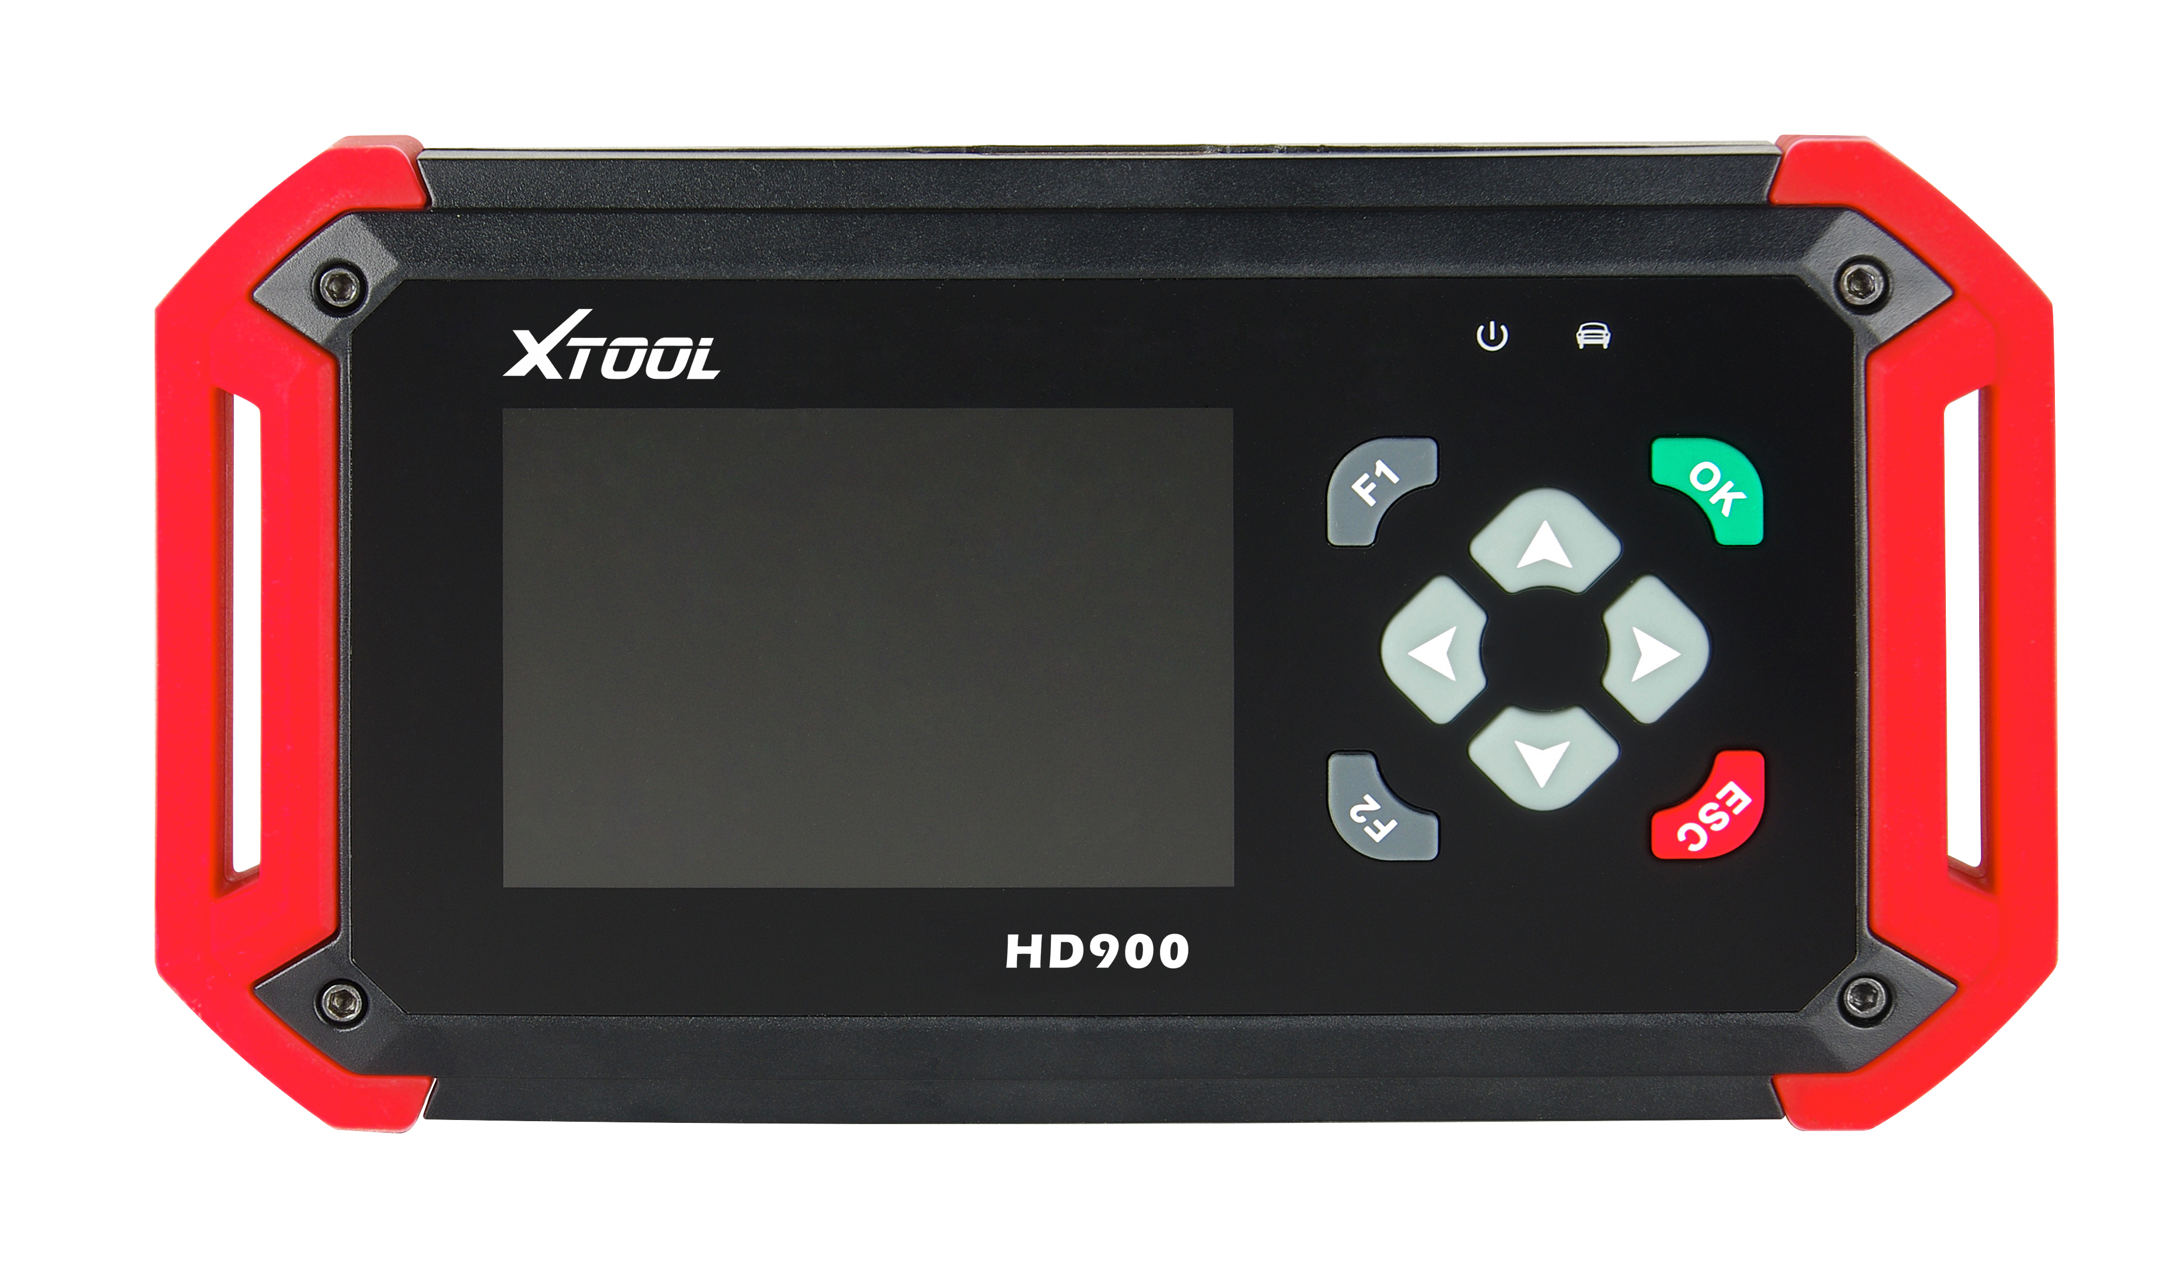
④
The appearance of product is subject to practicality.
No. | Name | Descriptions
① | Display screen | 3.5’’ TFT-LCD, showing testing options and results
② | Power indicator | After power on, it will turn to red color and always on.
③ | Communication Indicator | When communicating with the vehicle, it will turn to green color.
④ |  | Up or Down
 |  | Left or Right
 |  | Ok
 |  | Exit or Back to previous interface
 | 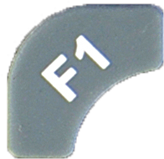 | Special function key,  Retrieve the keyboard and  input the words
 | 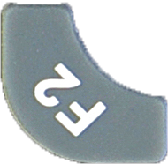 | Special function key, can be used as OK.

(2) Top view：

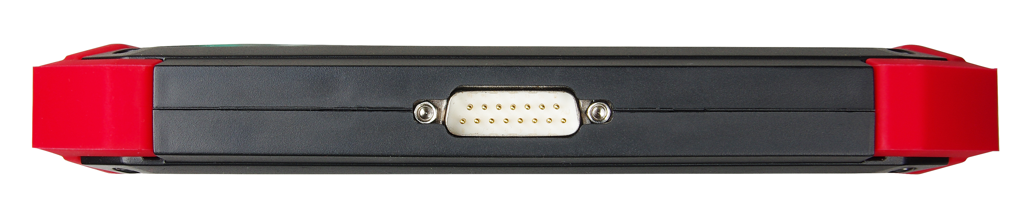
DB15 Port：Connect to the main test cable

(3) Down view：

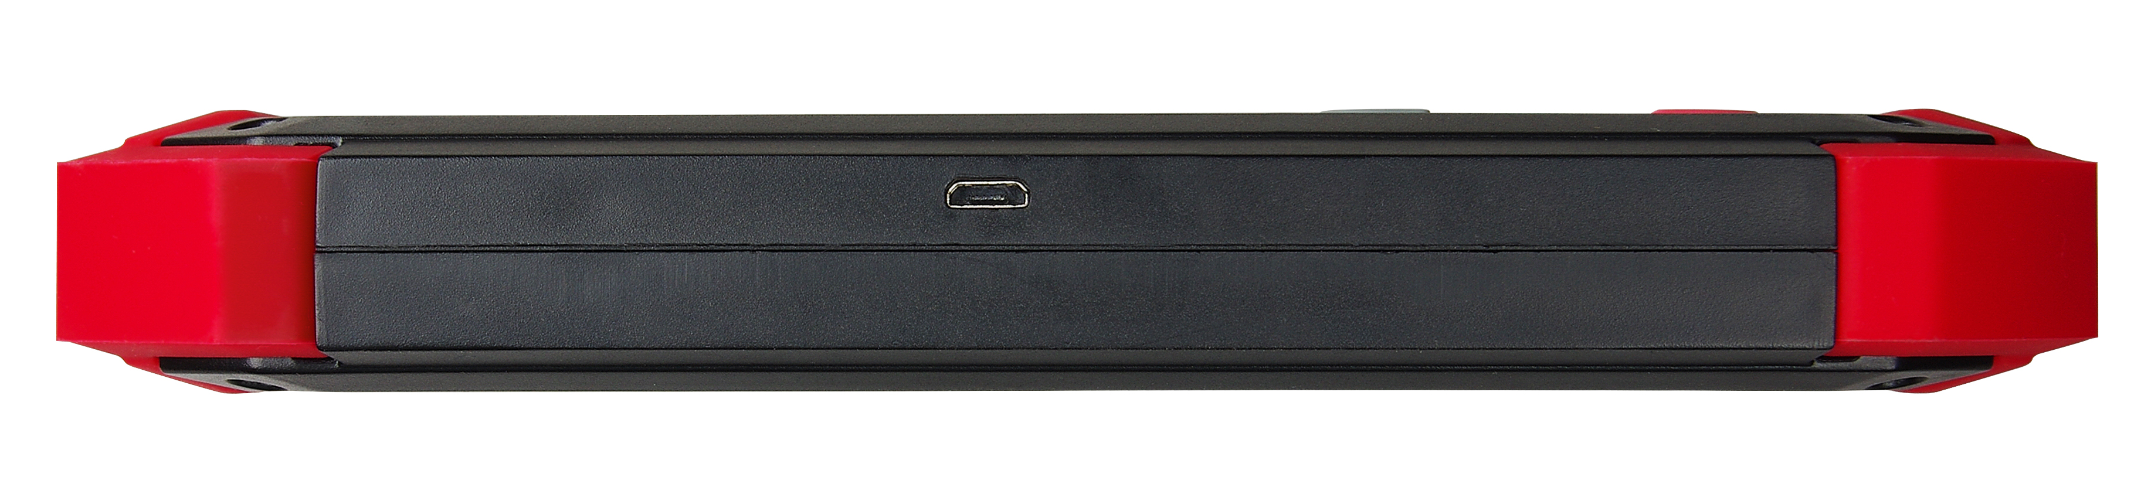
Micro USB Port: Connecting PC USB2.0 port with mini-USB cable to update SW

2. Technical Parameters
CPU: ARM 32bit CPU 72MHz
RAM: 64K RAM
Program Memory: 512K Flash
Internal Memory: built-in 2GB TF card
Input Voltage: DC 11~36V
External Interface: DB15/ Mini USB
Display: 3.5’’ TFT-LCD Display
Components: Main frame, Test cable, USB cable
Operating Temperature: -20—50℃
Humidity: <90%
Dimension (L*W*H): 7.48’’(L) x 3.94’’(W) x 1.06’’(H)

Chapter Ⅱ Diagnose

1. Vehicle Connection Diagnosis
(1). Connect the DB15 connector of test cable to the HD900 main frame and the 6/9 pin connector to the vehicles DLC port. (Shown as follows)
(2). Switch on the ignition and turn on HD900 to test vehicles.
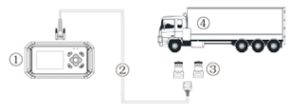
① HD900 main frame ② Test cable
③ 6/9 Pin Truck Connectors ④ Vehicle

2. HD900 Main Interface
The main interface is shown as below. Select “Function” to test vehicles; Select “Options” to enter the settings menu; Select “About” to check the software version, serial number, etc.; Select “Selftest” to do HD900 self-test.

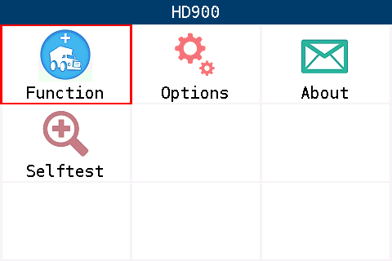

3. OBDII Diagnosis
(1). Select “Function” in the main interface to do OBDII diagnosis.
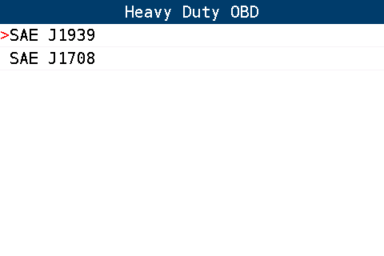

(2). Users can choose the protocol according to his vehicle for diagnosing.
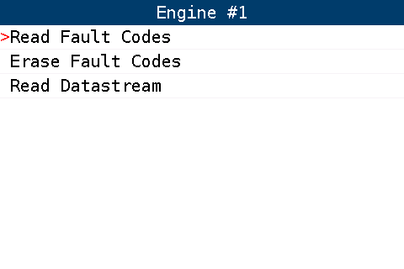
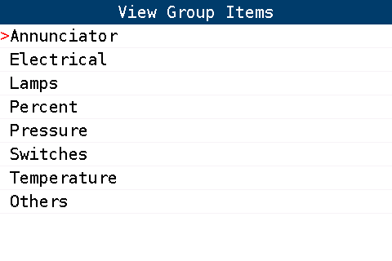

Chapter Ⅲ Setting

Select “Options” in the main interface to enter the settings menu.
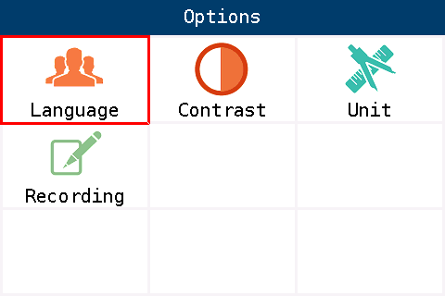
- Language Setting
Only English language.
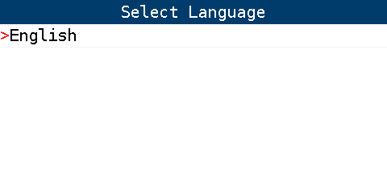

2. Contrast Adjustment
Select “Contrast” and press Left and Right to adjust the contrast; press OK to save settings.
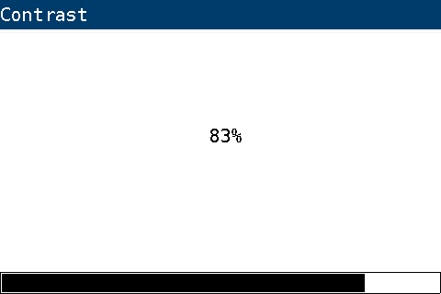

- Metric/English Units
Select “Unit” and press Up and Down to choose unit; press OK to save settings.

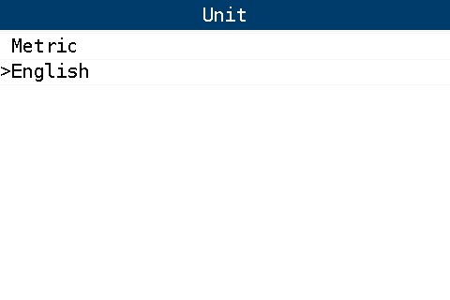
- Recording
When testing the vehicles, you can record the diagnostic results and give feedback to the after-sales department of XTOOLTECH. Select “Recording” and choose Disable or Enable.

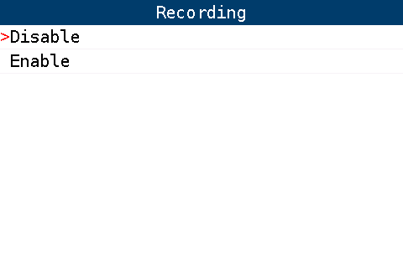

5. Information
Select “About” in the main interface to check the information, including the product serial number, hardware version, software version, password, etc.
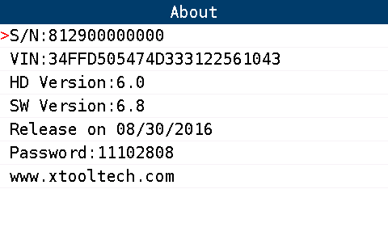

Chapter Ⅳ Update

1. Upgrade Tool Installing
(1). Visit XTOOL website: http://www.xtooltech.com.
(2). Click the icon of “Upgrade Tool” (shown as below), then download the Upgrade Tool and save the file to your computer.

(3). Follow the instructions step by step to install the Upgrade Tool.

2. Software Updating
(1). Connect the HD900 main frame to the computer via USB cable.
(2). Open the Upgrade Tool, input the Product SN and Password, then click Login. (shown as below)

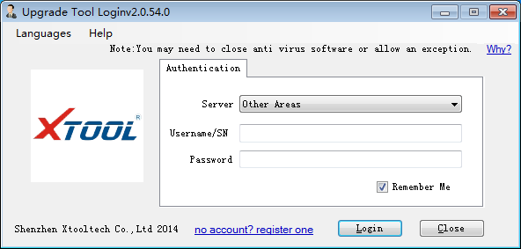

(3). After login, you will see as below; click “(Un)Sel” to select the software and click “Upgrade” then it will update automatically.

